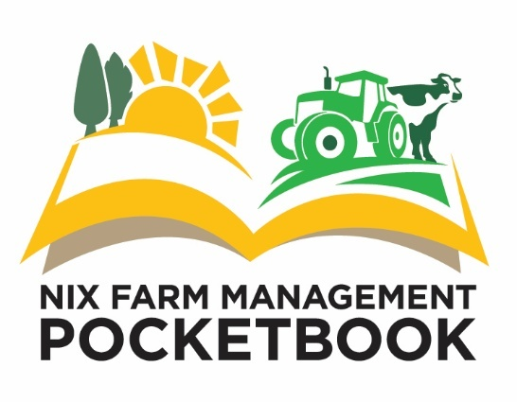

Dear Abi,
Here is a Press Release highlighting the challenges in UK farming occurring at present being greater than the 60-years of Nix Pocketbook history. We would be very grateful if you would feature it in your publications.
If you ever require economic commentary or data throughout the year, please feel free to contact me, I will do what I can to support you.

Best wishes and kind regards
Graham Redman
More Challenges in Farming than for 60 Years
There are greater challenges in UK farming than for any of the 60 years the Nix Farm Management Pocketbook has been recording farm performance, despite good profits in some sectors
Farm profits in the UK hit their highest point ever in nominal terms in 2025. Once adjusted for inflation, real-term profits per farmer came second only to 2022, greater than it was in the heady days of the mid-1990’s. Farming, for some, mostly those with livestock, has recently been very profitable.
Yet at the same time, there are emerging challenges that are stretching the industry, in some cases to breaking point. These challenges are not acute and sudden that grab headlines and attention, but chronic and slow, that gradually increase, putting farming under financial strain.
Unprecedentedly dry fields have hampered arable and grass yields alike, giving arable farmers low yields and livestock farmers animal welfare challenges let alone keeping stock productive. Two exceptionally dry summers does not make a trend and next year could be a washout, but extremes are being hit. Farmers are used to weather challenges, but climate change is bringing with it new demands on farm capacity to prepare for extremes. Greater forage storage, drought resistant crop varieties and water capture systems would make droughts more manageable. Cow tracks and field and yard drainage is also required for greater farm resilience to weather. It all comes at a cost.
Rising costs such as fertiliser and fuel as a result of the closure of the straight of Hormuz, are squeezing already tight margins. The mandatory rise in labour rates poses questions on how to get jobs done. Does a farm pay more for labour, mechanise, or look for alternative solutions such as contracting? Such challenges compound in commodity markets where margins are, by definition tight, and prices generally dictated by global markets, not the costs of production on farm.
The size of the challenge for British farmers has become greater than potentially the 60 years that the Nix Farm Management Pocketbook has been published. This is the stark conclusion made by author Graham Redman at the launch of the new Edition for 2027, which marks 60 years since the first Edition.
The table shows the whole farm figures budgeted for 2027 by the Nix Pocketbook. They show a profit for all main sectors of broadacre farming next year, although the very slim margin in the arable sector is dependent on both support and diversification, another defining change taking place on British farms. Profits rise for those farms without rent, finance and with unpaid labour, describing how so many farms are viable in low profit years.
Nix Pocketbook’s Whole Farm Costings - Summary
2027 Whole Farm Figures |  |  |  |  |  |  | Lowland |  |  | Upland
£/Ha | Combinable Crops |  |  | Dairy |  |  | Beef & Sheep |  |  | Beef & Sheep
Performance level | Average | High |  | Average | High |  | Average | High |  | Average | High
Farm Gross Margin | 920 | 1,130 |  | 2,998 | 3,378 |  | 1,180 | 1,757 |  | 547 | 813
Total Fixed Costs | 885 | 797 |  | 2,090 | 1,881 |  | 1,060 | 954 |  | 540 | 486
Margin Before Rent & Finance | 35 | 334 |  | 908 | 1,497 |  | 120 | 803 |  | 7 | 327
Less Rent & Finance | 160 | 160 |  | 295 | 295 |  | 150 | 150 |  | 80 | 80
Plus Support & Diversification | 134 | 139 |  | 106 | 111 |  | 250 | 261 |  | 170 | 173
Business Profit (Loss) | 9 | 312 |  | 719 | 1,312 |  | 220 | 913 |  | 97 | 420
Ex. unpaid labour, rent, finance | 269 | 562 |  | 1,534 | 2,075 |  | 770 | 1,423 |  | 377 | 680

The Pocketbook is updated for 2027 costed for the year ahead, overheads, capital and other farming costs. It helps farmers, students and other agribusiness professionals to understand their farms, the industry and the opportunities that it offers. To support the farming industry, the price of the Pocketbook has been frozen at last year’s level.
Furthermore, the Nix Pocketbook is now available online. Those who opt for the online version also have access to additional details, analysis and decision making tools which will become live on the Pocketbook website throughout the year.
Visit www.thepocketbook.co.uk to purchase a copy, view the contents and examine some sample pages of the book and to log into your online portal.




EDITORS NOTES:
552 words plus table: For more information visit https://theandersonscentre.co.uk/nix-pocketbook/ , contact Graham Redman on 07968 762 390 or email him at gredman@theandersonscentre.co.uk
For your own press copy for quoting in articles and publications, please send your correct details and postal address. If you require commentary on any other financial aspect of UK farming, please feel free to make contact.

Graham
Graham Redman
Editor, The Nix Farm Management Pocketbook
+44 (0) 7968 762 390
https://www.linkedin.com/in/graham-redman-b084411a/

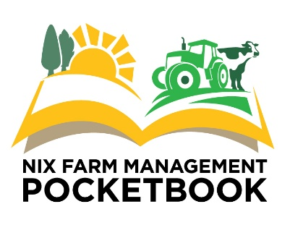
www.theandersonscentre.co.uk
Floor 3 The Tower, Pera Business Park, Melton Mowbray, Leicestershire, LE13 0PB, UK.
01664 503 200
This e-mail and the information it contains may be confidential, legally privileged and protected by law. Any liability arising from any third party acting, or refraining from acting, on any information contained in this e-mail is hereby excluded. If you are not the intended recipient, please notify the sender immediately and do not disclose the contents to any other person, use it for any purpose, or store or copy the information in any medium. Copyright in this e-mail and attachments created by us belongs to The Andersons Centre LLP. The Andersons Centre LLP systems are checked thoroughly for any type of contamination or corruption and attachments to this e-mail should not contain viruses. However, please check before opening the file as new viruses appear every day. The Andersons Centre LLP will not accept liability for loss or damage that may occur as a result of viruses.

